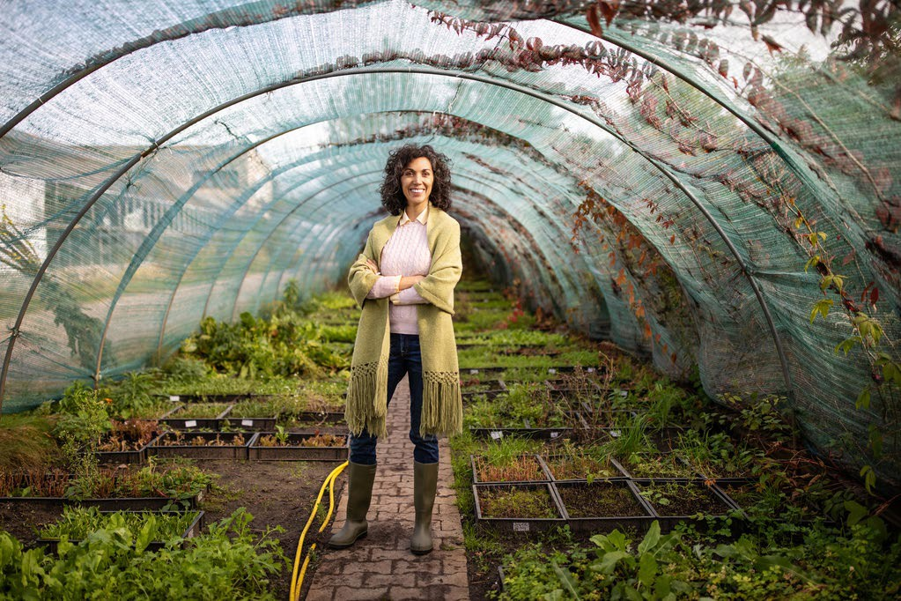

|  |  |  |  |  |
| --- | --- | --- | --- | --- |
| Next Step Community Garden  Take your weekends back. Summer is here!  Let us do the dirty work so you can enjoy it | | |  | May 2021 Issue 1 |
|  | | |  | In this issue  News from the garden  See our progress  Our Mission  Why we decided to start a Community Garden  How you can help  Donate and volunteer! |
| News from the garden |  | We are in week 5 of our first community garden! We have had some ups and downs, and are learning more about how to grow and care for our garden. Our Next Steppers are in awe of how much their hard work is paying off and love seeing their plants grow!  Our current list of vegetables is as follows:  Squash, Cucumber, Mesculin, Beet, Radish, Pepper, Tomato, Basil, Green Onion and much more! | | |

|  |  |  |  |
| --- | --- | --- | --- |
|  |  |  | |
| person pushing wheel barrel of plants How you can help Donate! We update frequently about our progress and any supplies that we may need. By donating, you enable our garden to come together quickly and efficiently, and help our young adults learn valuable skills about patience, commitment, responsibility, problem solving, decision making and teamwork.  Volunteer! Our young adults work hard to maintain the Community Garden. It’s growing fast! However, we are in desperate need of volunteers to help build and maintain it. Our Garden needs at least 6 more planter boxes so that we can transplant our seedlings and we also need help planning and executing other phases of the project.  If you would like to Volunteer, please grab a sign up sheet to reserve a time! |  | group of people posing inside a greenhouseOur Mission |
| Throughout the past year, we have seen unprecedented changes to our daily life and a dramatic increase in food insecurity throughout the country. It is so important to us at Next Step to make an impact, not only on the lives of our young adults but through our community as a whole.  All of the produce grown in our garden will be available to our young adults, volunteers, and those in need in our community.  Come help us grow! |